**Lab Exercise 20**

**Creating a Pipeline Script**

**Objective:** To create a pipeline script for automating build processes in Jenkins

**Tools required:** Jenkins

**Prerequisites:** None

Steps to be followed:

1. Log in to the Jenkins CI tool and create a pipeline script

**Step 1: Log in to the Jenkins Cl tool and create a pipeline script**

1. Open the browser, go to the Jenkins **Dashboard** by typing **localhost:8080** in your browser, provide the credentials, and click the **Sign in** button

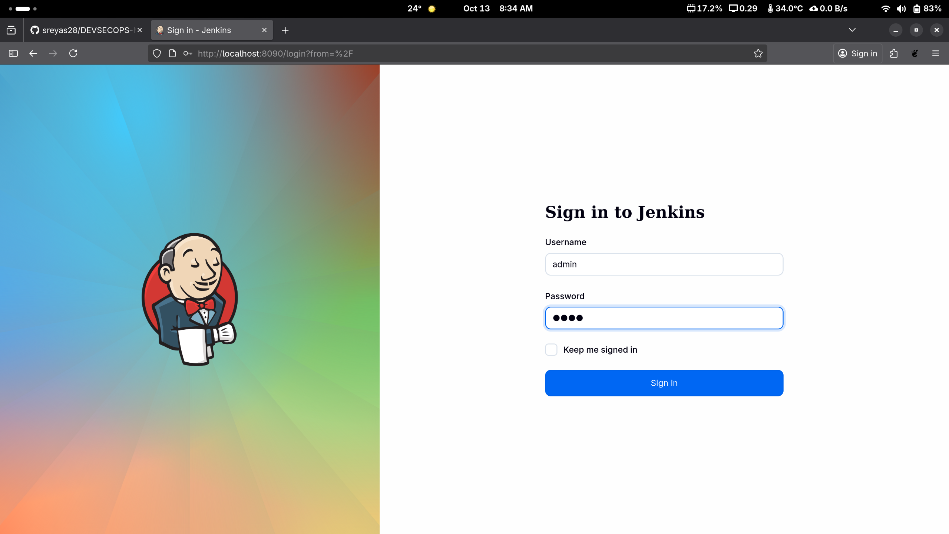

|  |
| --- |
| **Note:** The credentials for accessing Jenkins in the lab are Username: **admin** and Password: **admin**. |

1. Click on the **New Item** option as shown in the screenshot below:

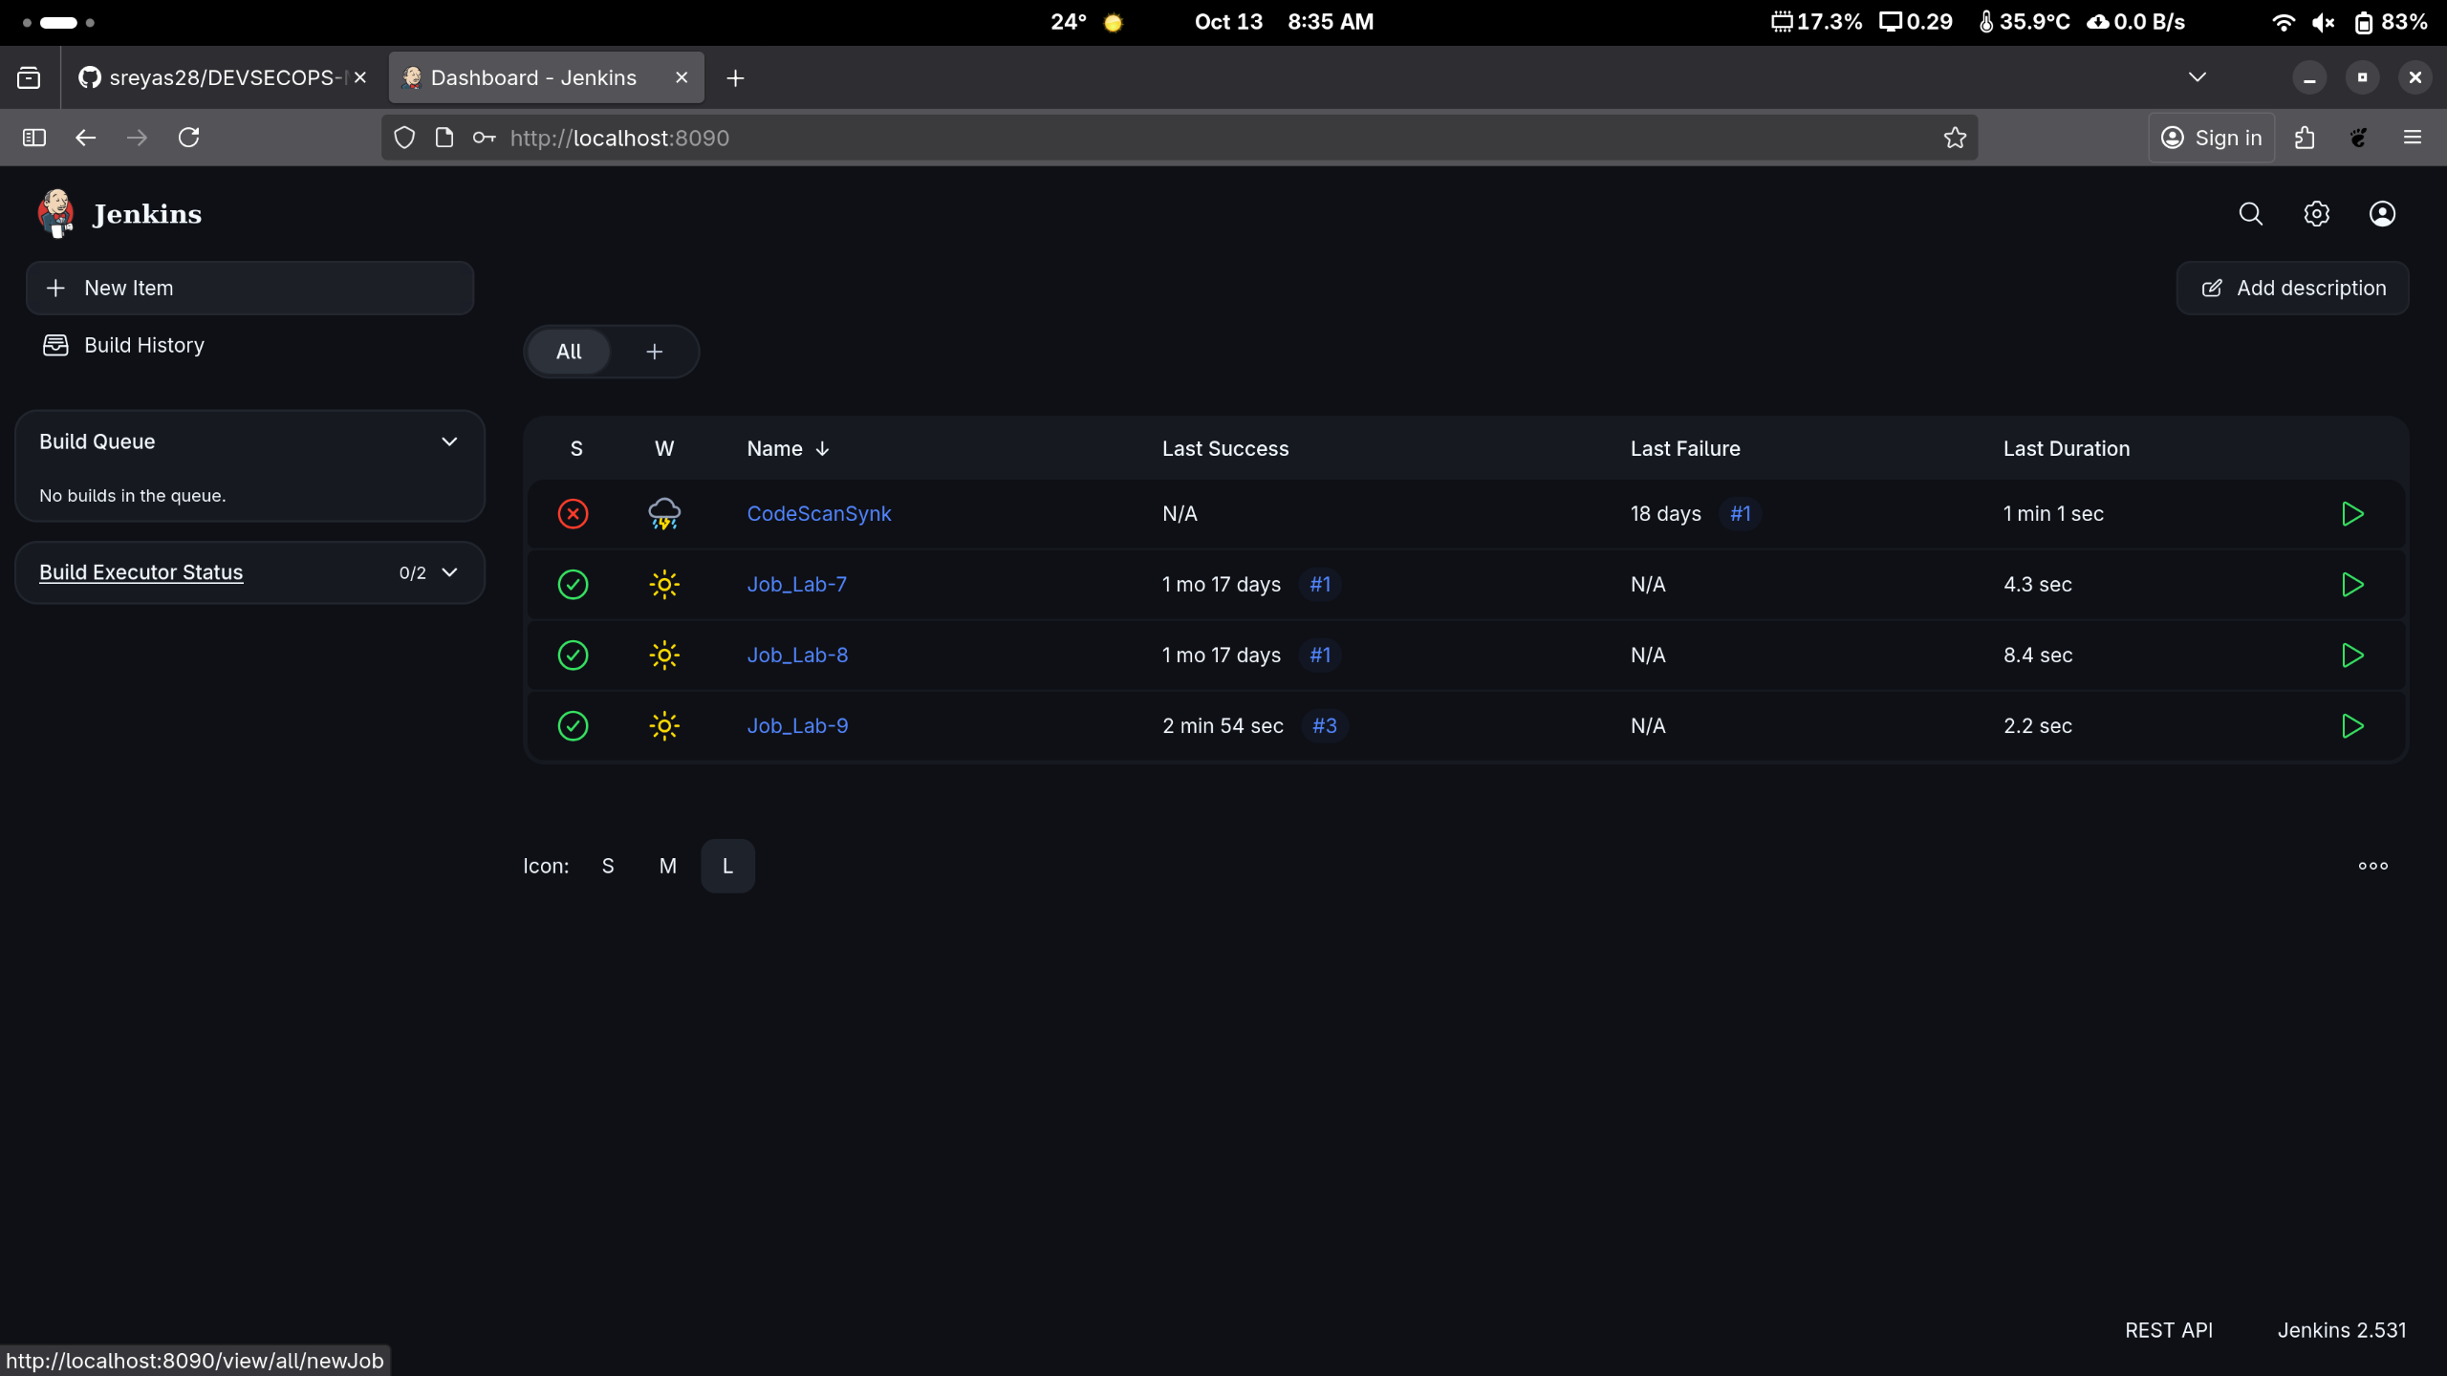

1. Enter a desired name for the project, select **Pipeline**, and then 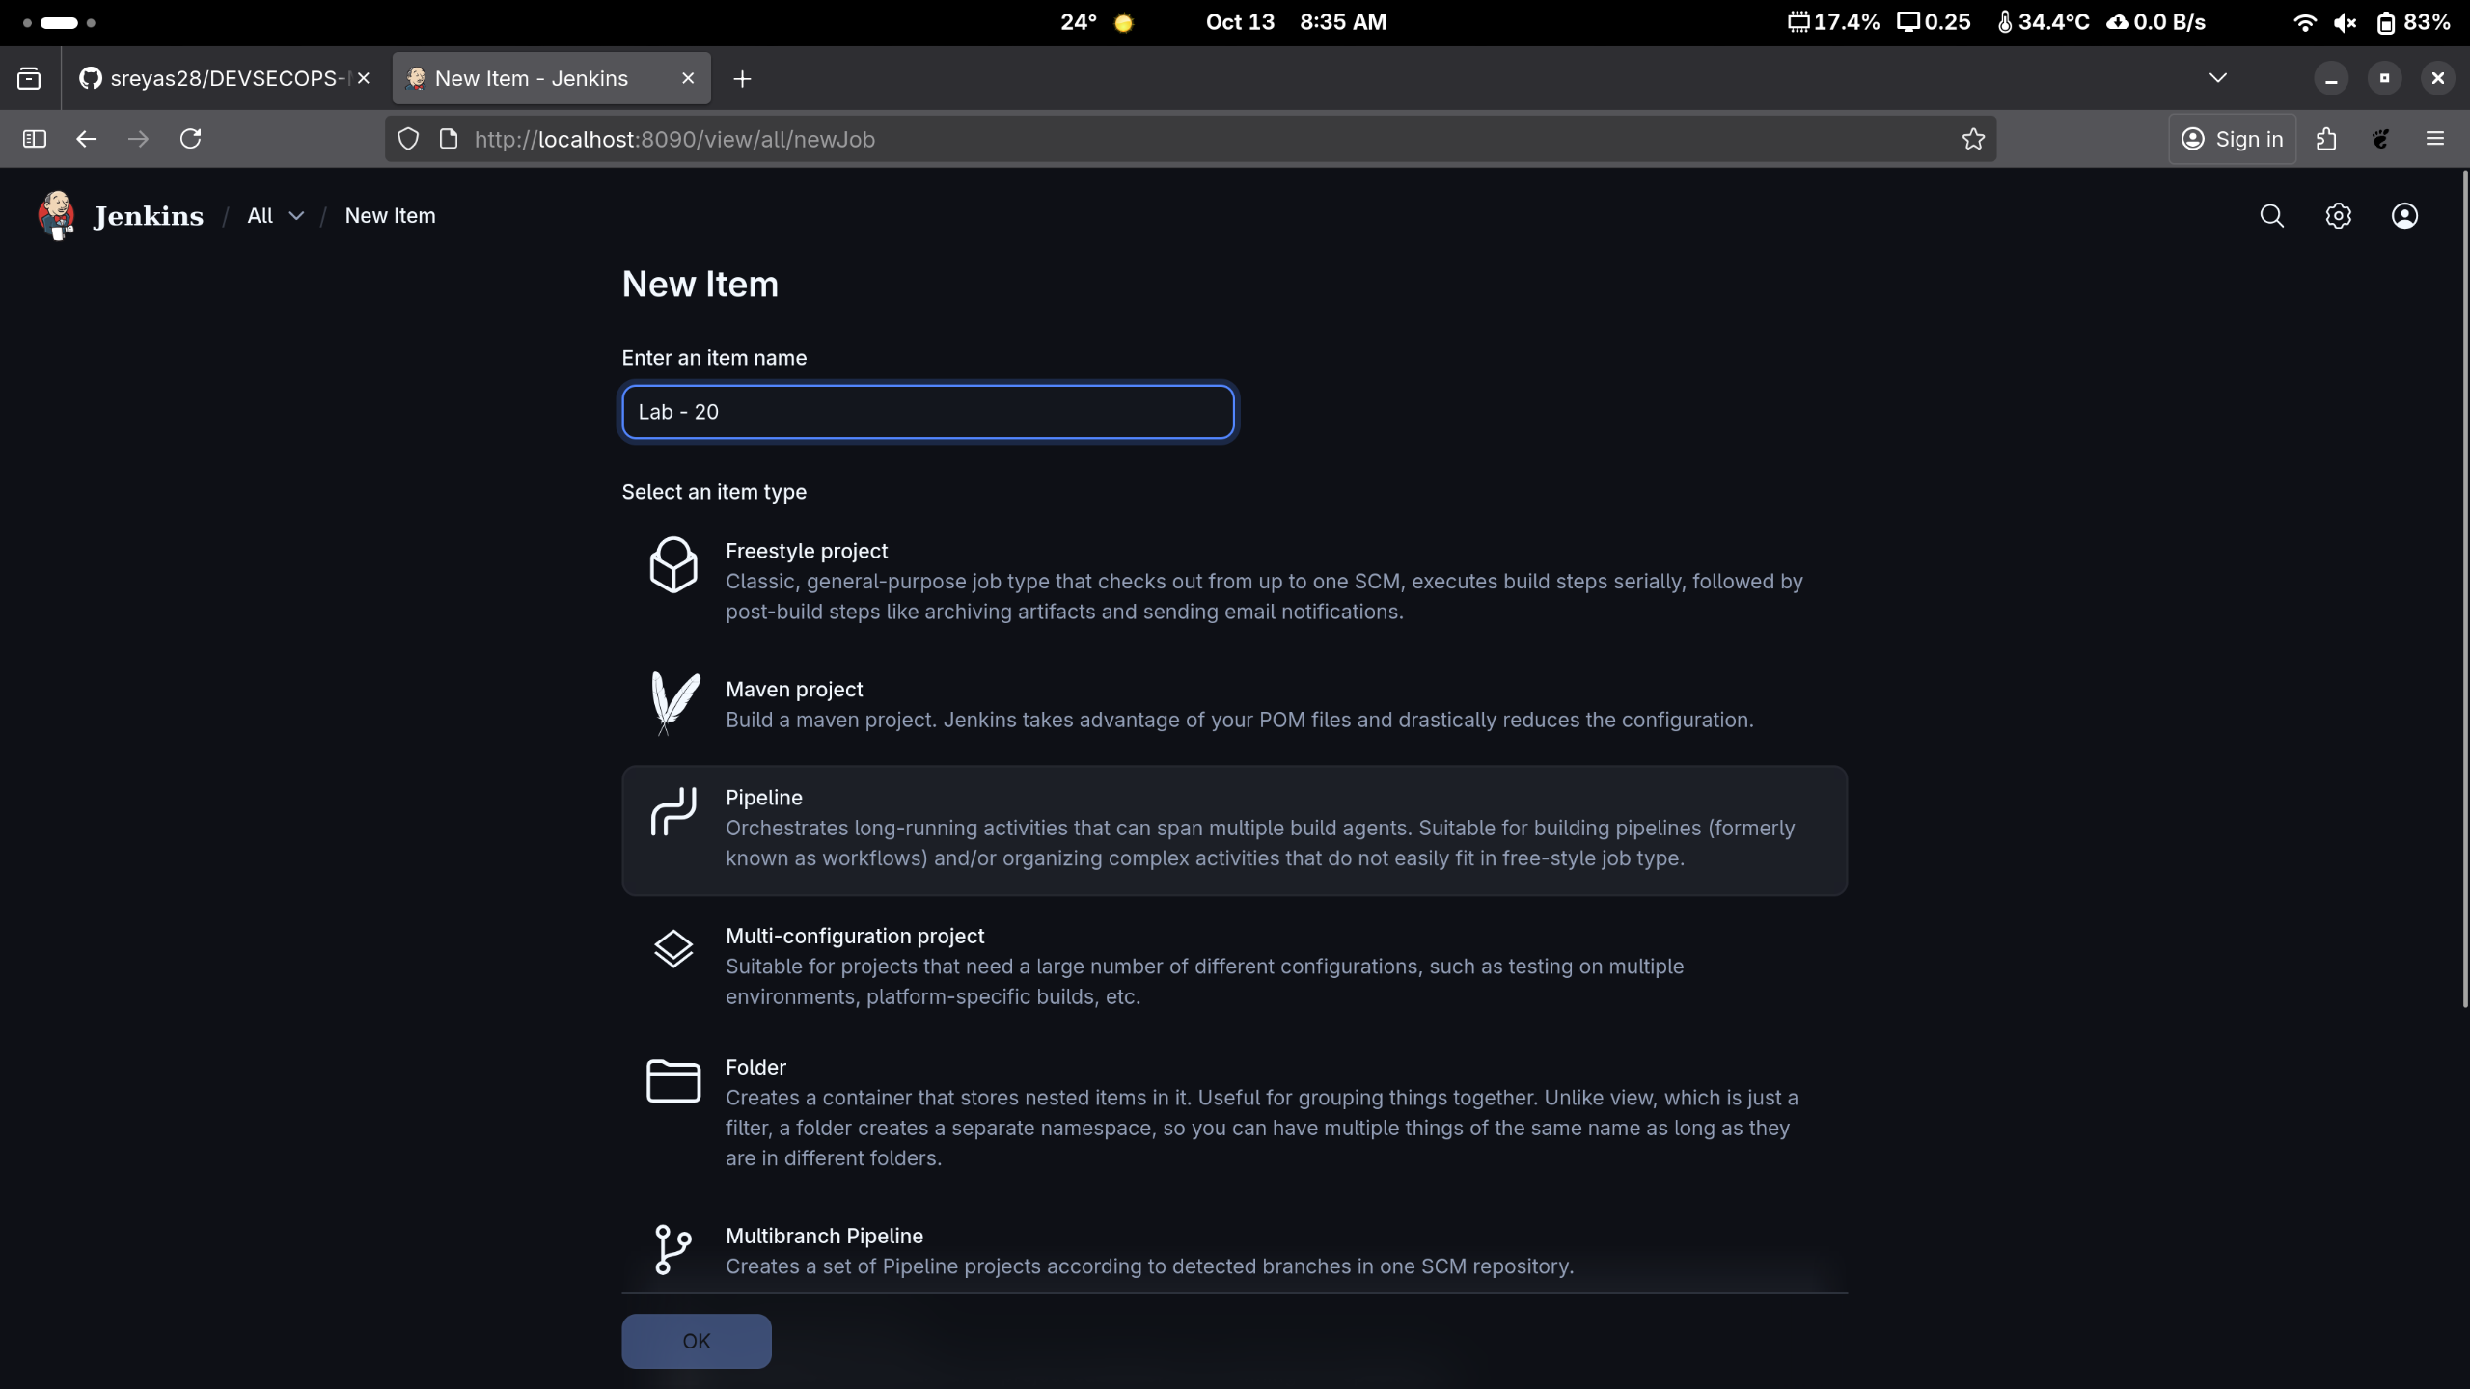click on **OK** as shown in the screenshot below:

1. Click on **Pipeline** as shown in the screenshot below:

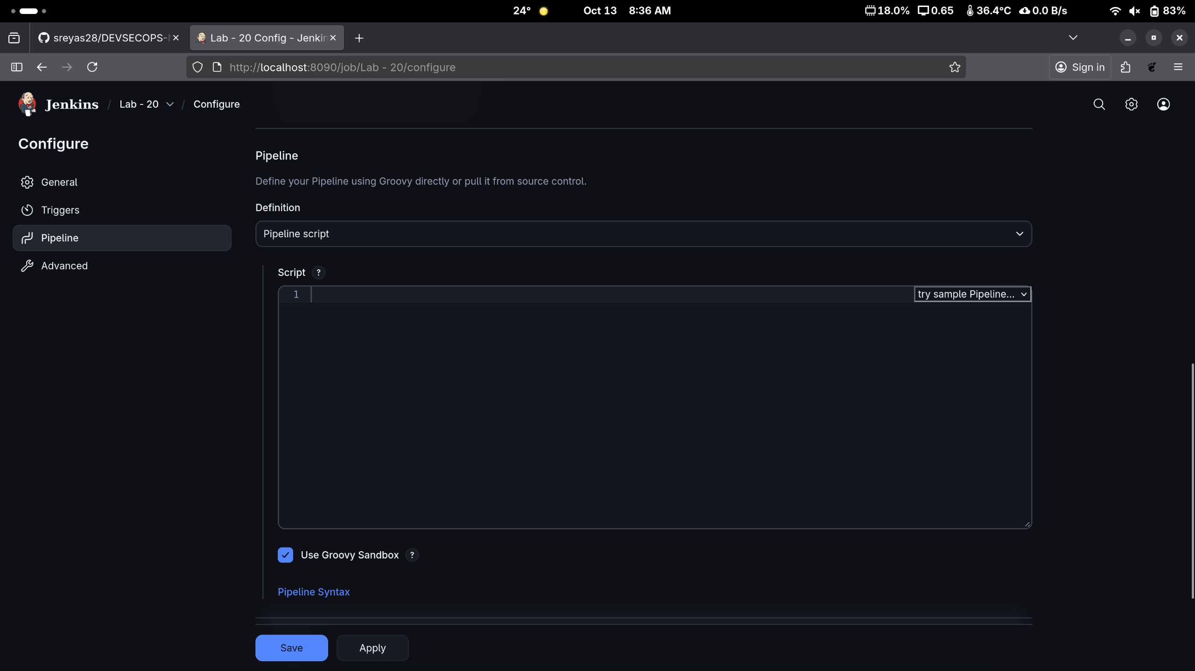

1. Enter the following pipeline script in the script editor and click on **Save** as shown in the screenshot below:

**pipeline {**

**agent any**

**stages {**

**stage("hello") {**

**steps{**

**echo"welcome to Jenkins pipeline"**

**}**

**}**

**}**

**}**

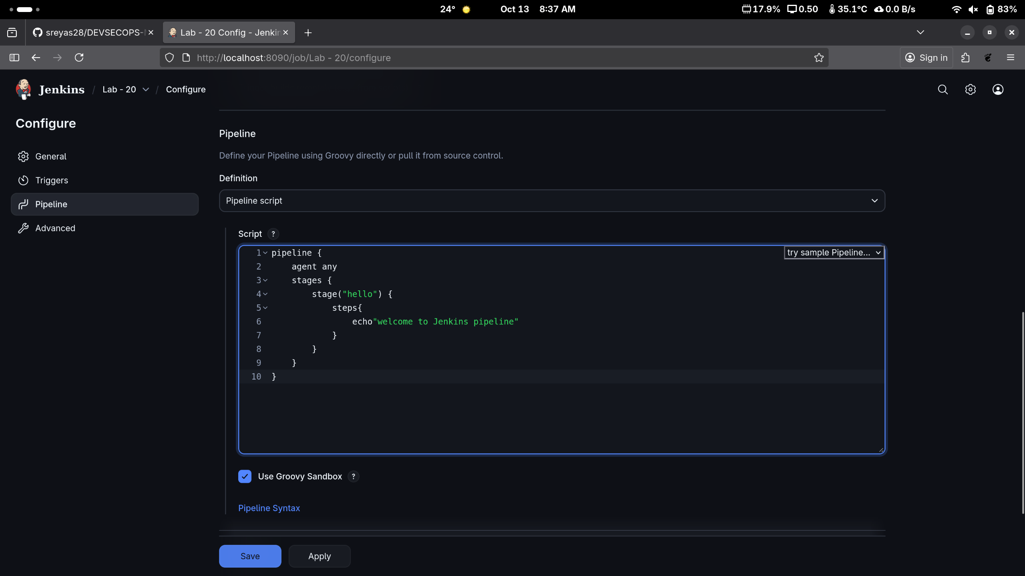

1. Click on **Build Now** to run the pipeline script as shown in the screenshot below:

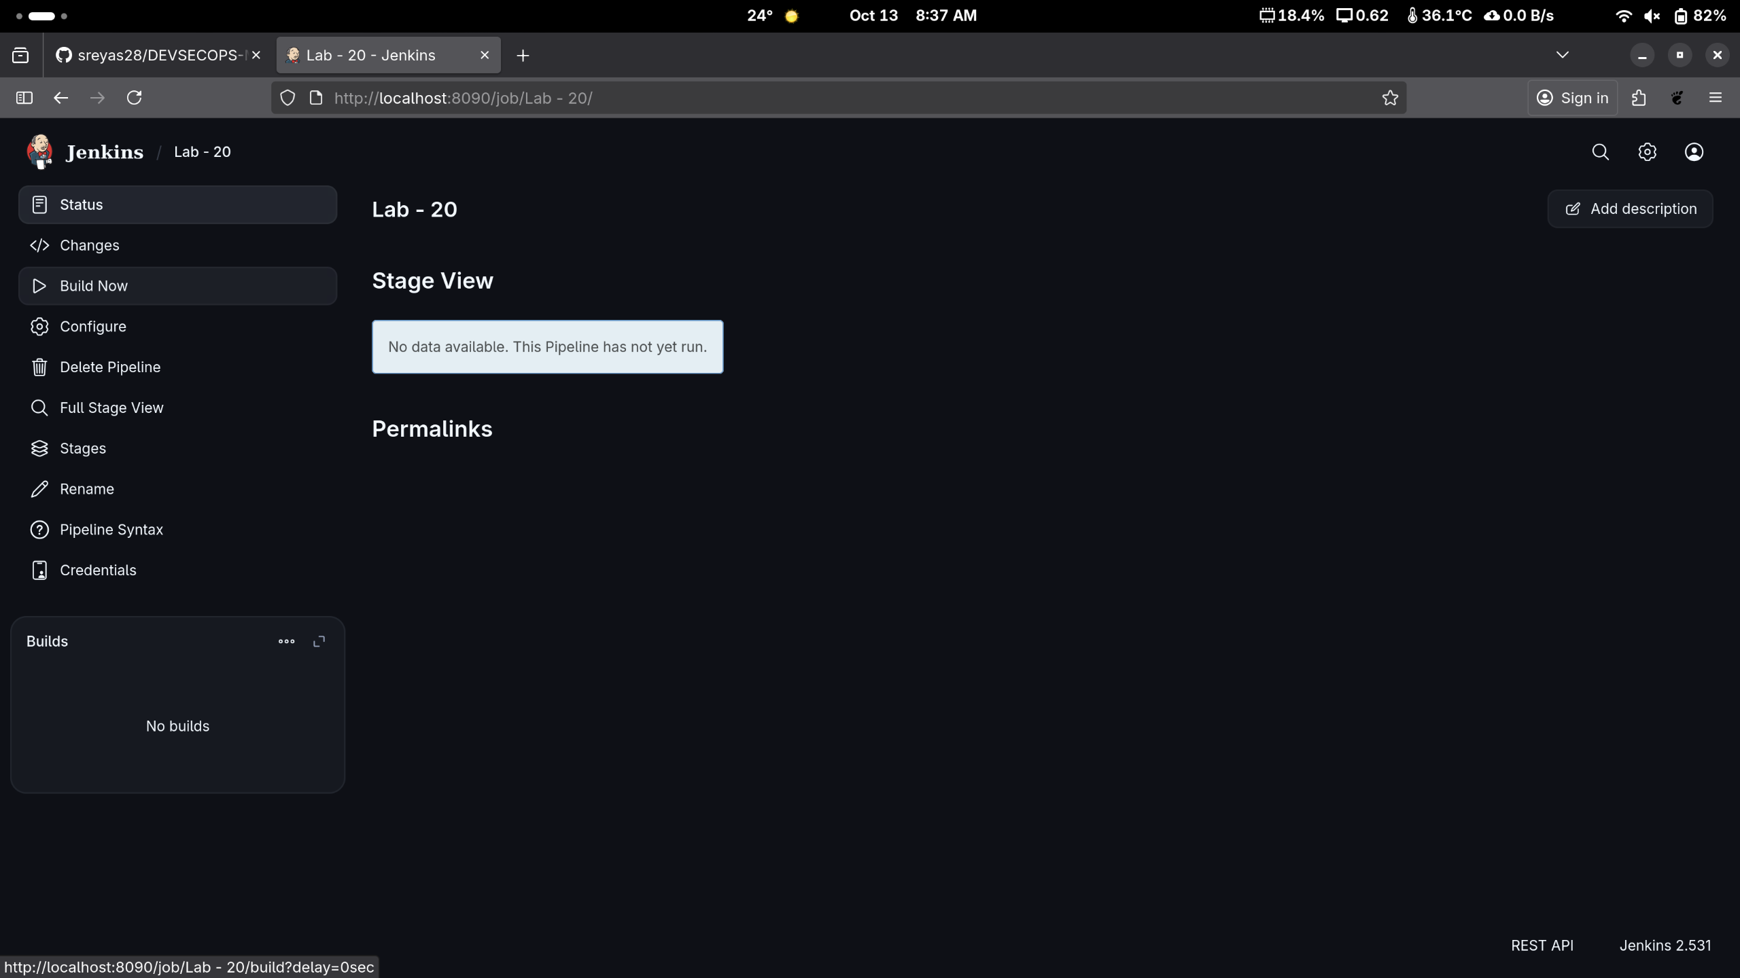

1. Hover over the milliseconds number next to the build stage name as shown in the screenshot below:

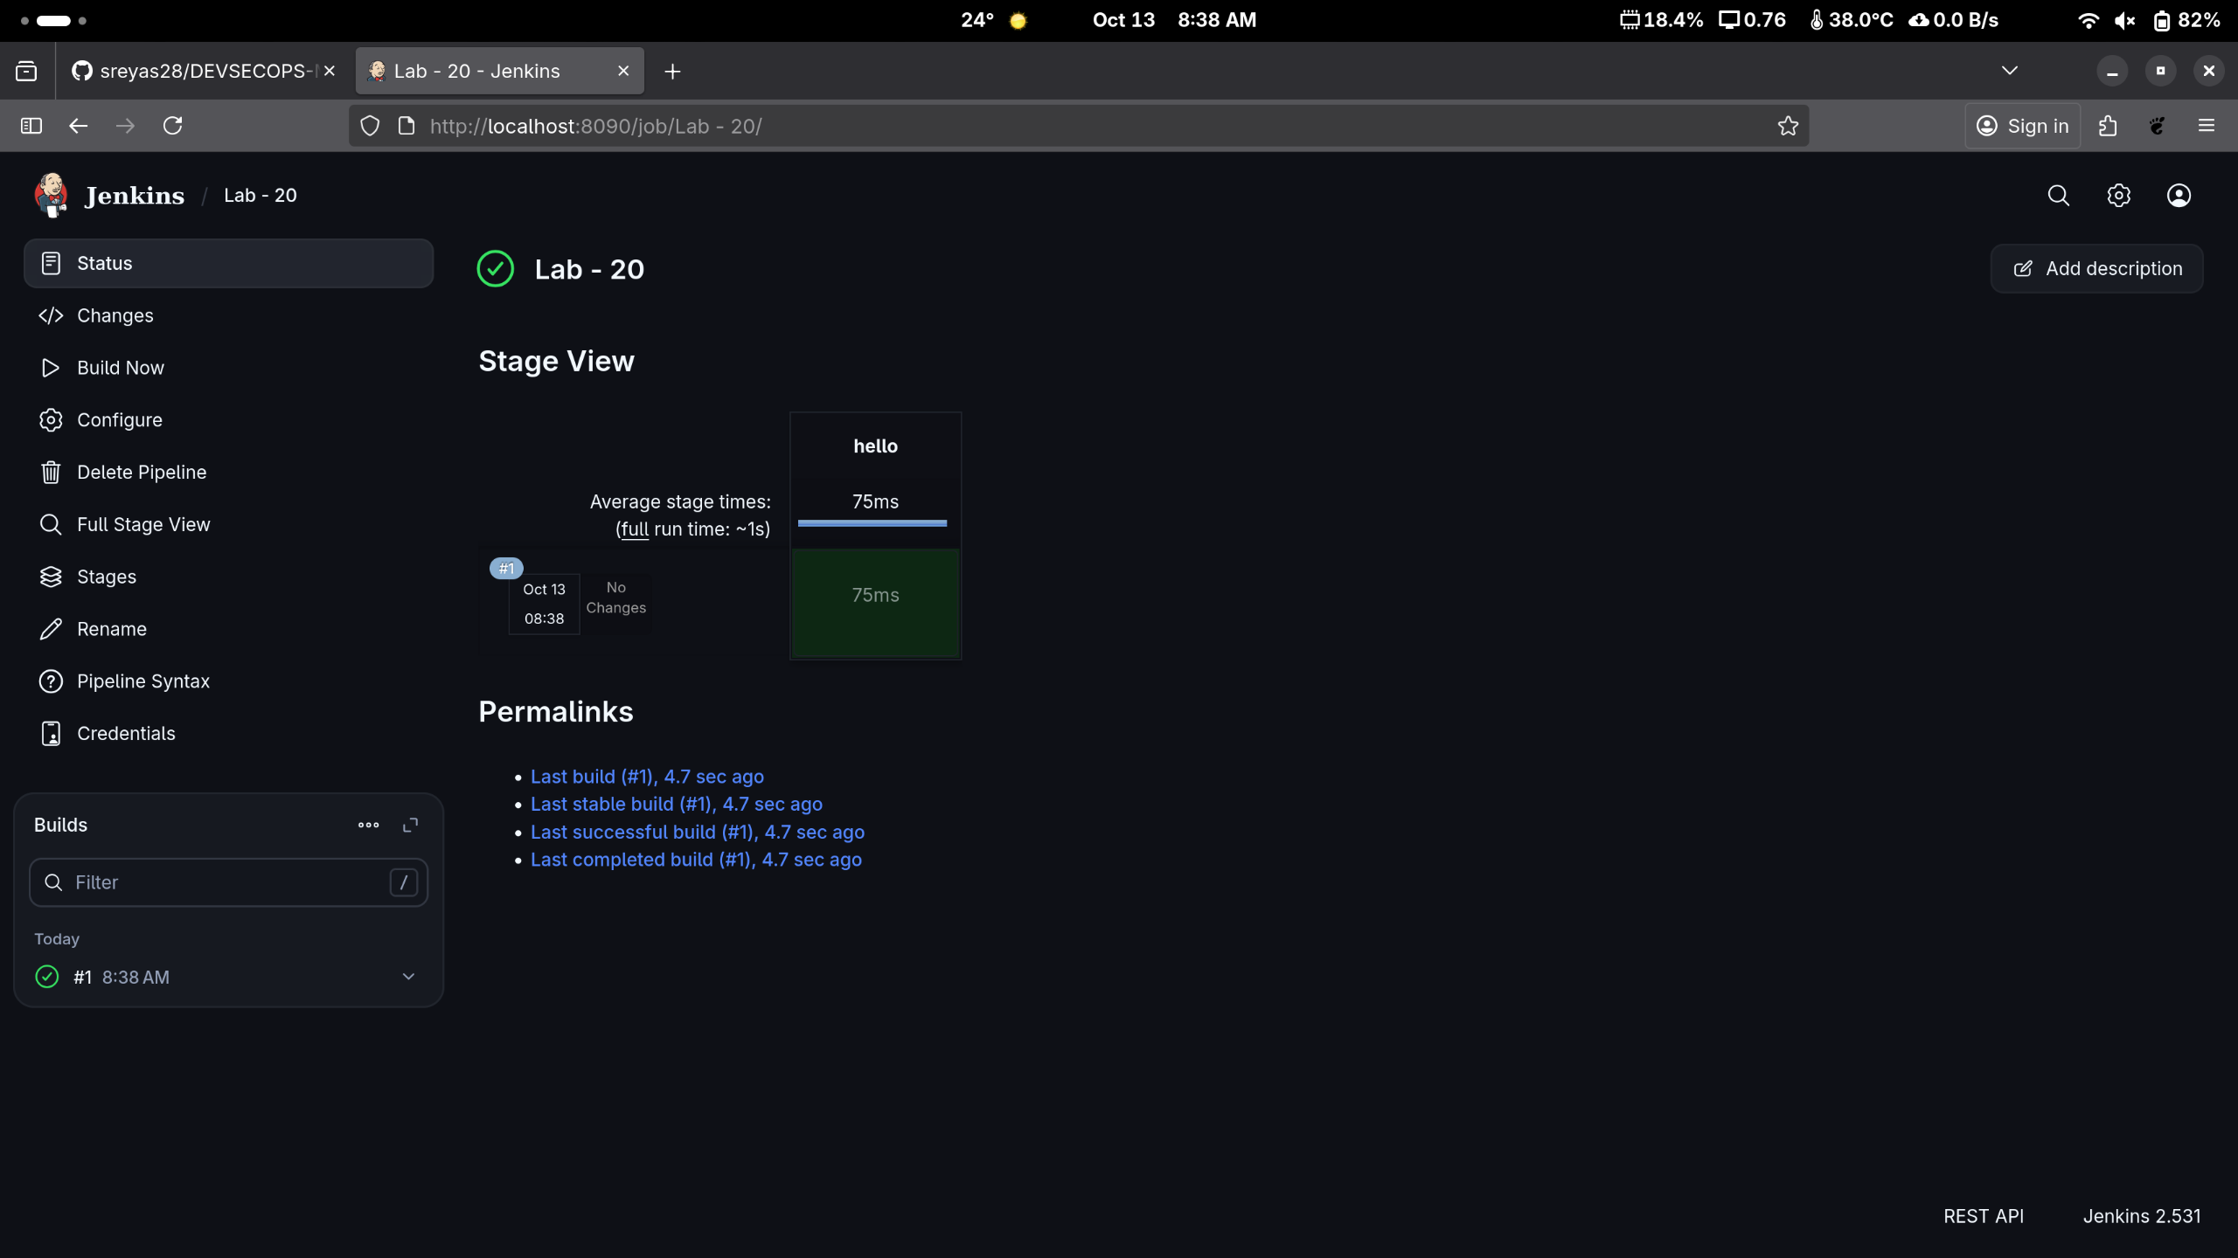

|  |
| --- |
| **Note:** Ensure that you hover the cursor over the milliseconds number without clicking on it |

1. Click on **Logs** as shown in the screenshot below:

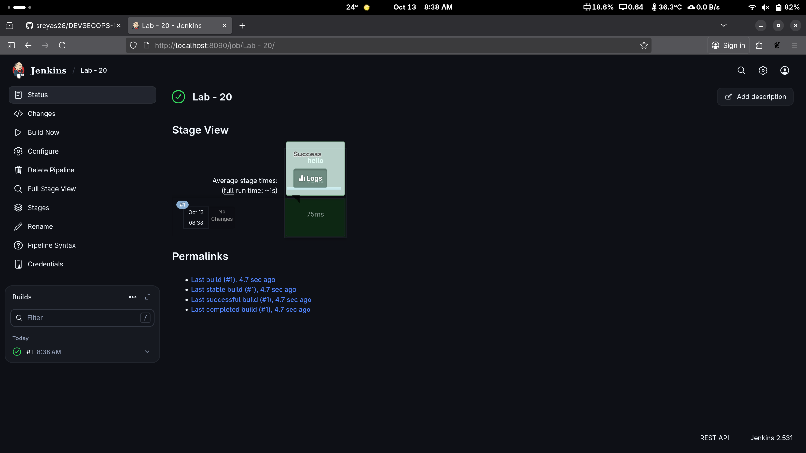

1. Check for the message in the top-left corner to confirm the successful execution of the pipeline stage as shown in the screenshot below:

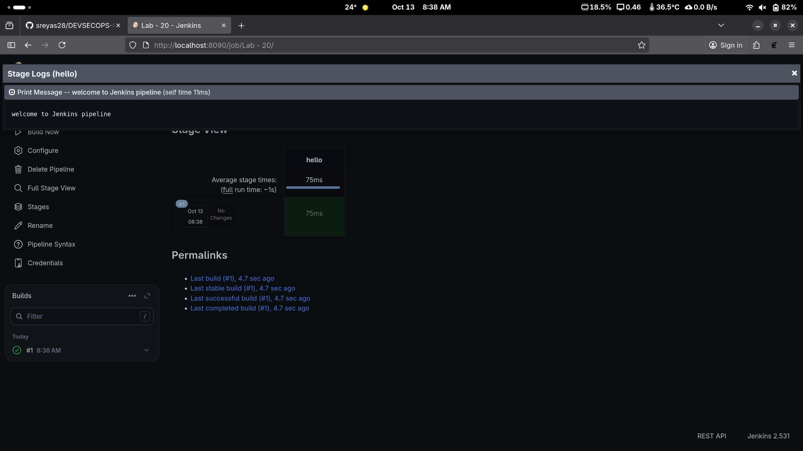

By following these steps, you have successfully created a pipeline script for automating build processes in Jenkins.

**To Create a Pipeline Using A script from SCM.**

Step:1 Make a New Job Using PipeLine type

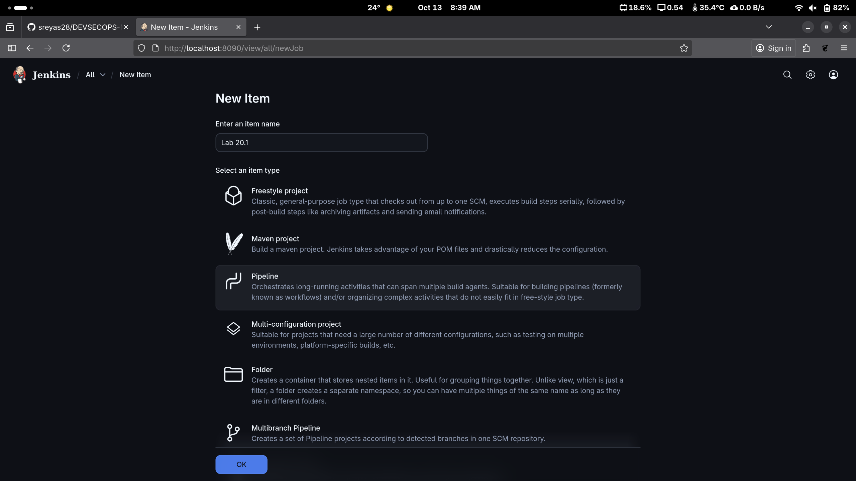

Step:2 Copy the Url of The GitRepo for Next steps.

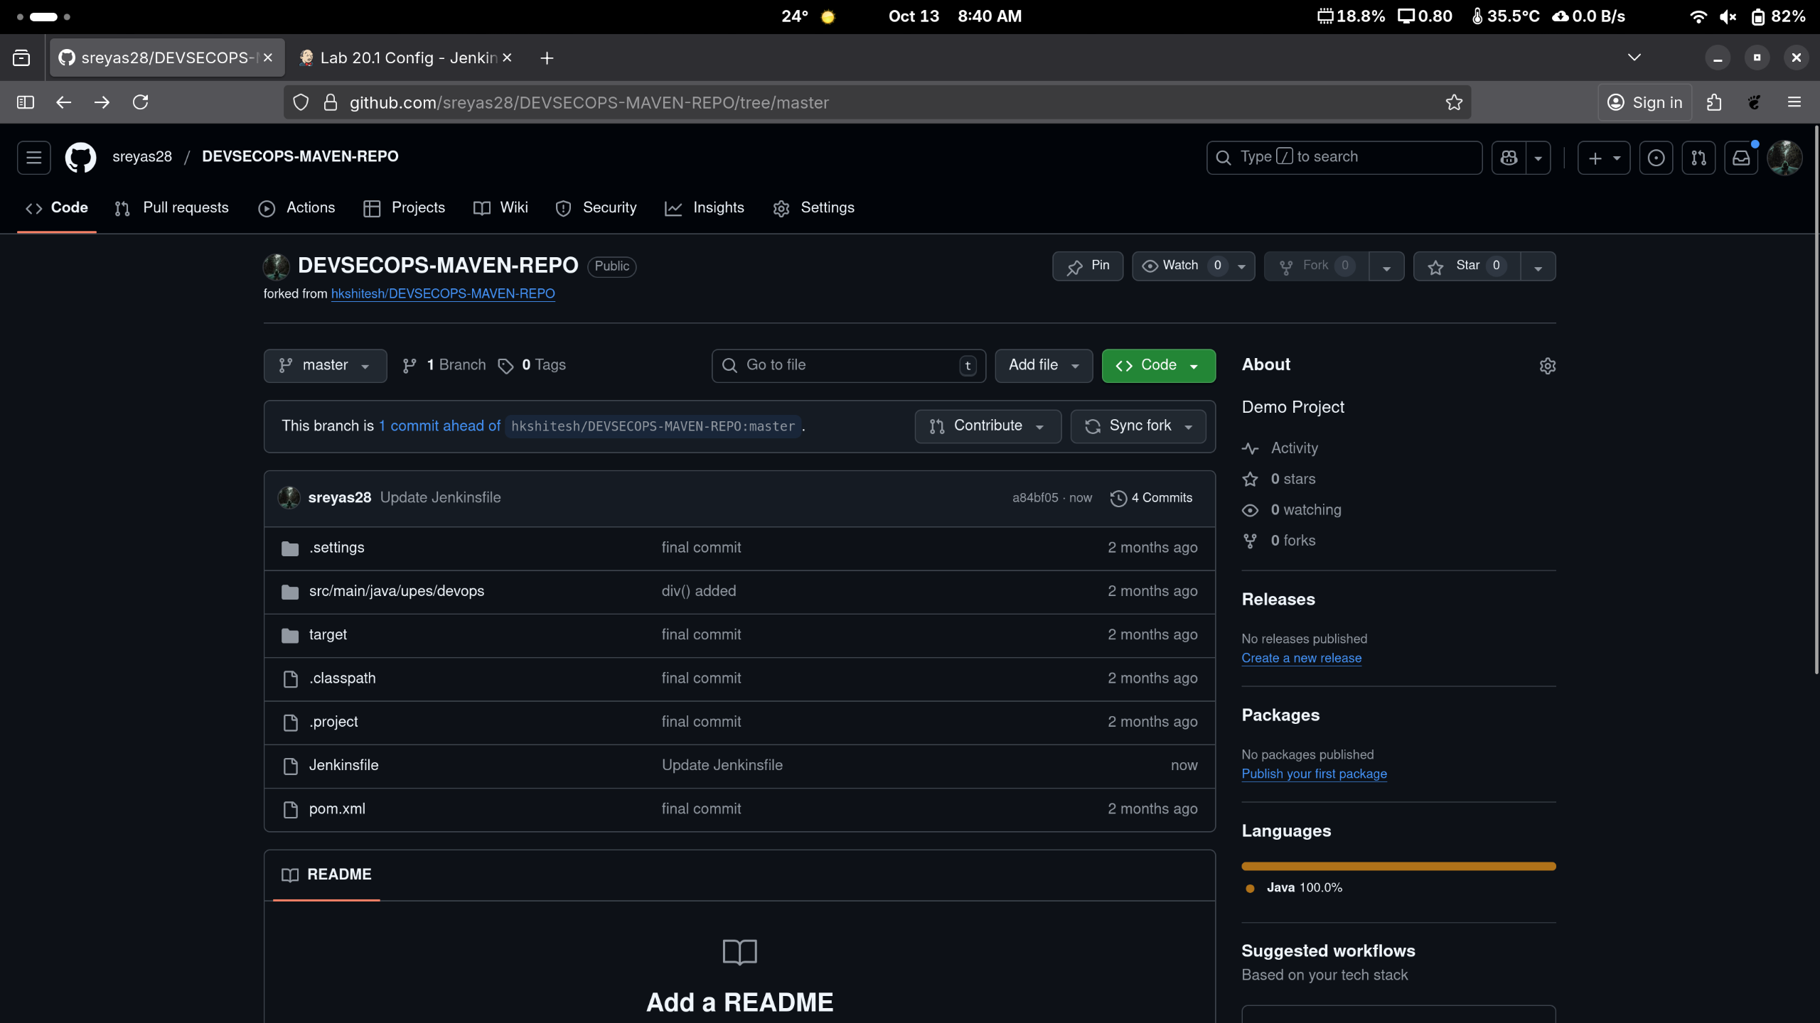

Step 2.1 JenkinsFile Contains following Things.

pipeline

{

agent any

tools

{

maven 'Maven_Home'

}

stages

{

stage('Welcome Stage')

{

steps

{

echo 'Welcome to Jenkins Pipeline'

}

}

stage('Clean Stage')

{

steps

{

sh 'mvn clean'

}

}

stage('Clean Success Stage')

{

steps

{

echo 'clean success'

}

}

stage('Build & Install Stage')

{

steps

{

sh 'mvn install'

}

}

stage('Build Success')

{

steps

{

echo 'Build successful'

}

}

}

}

Step:3 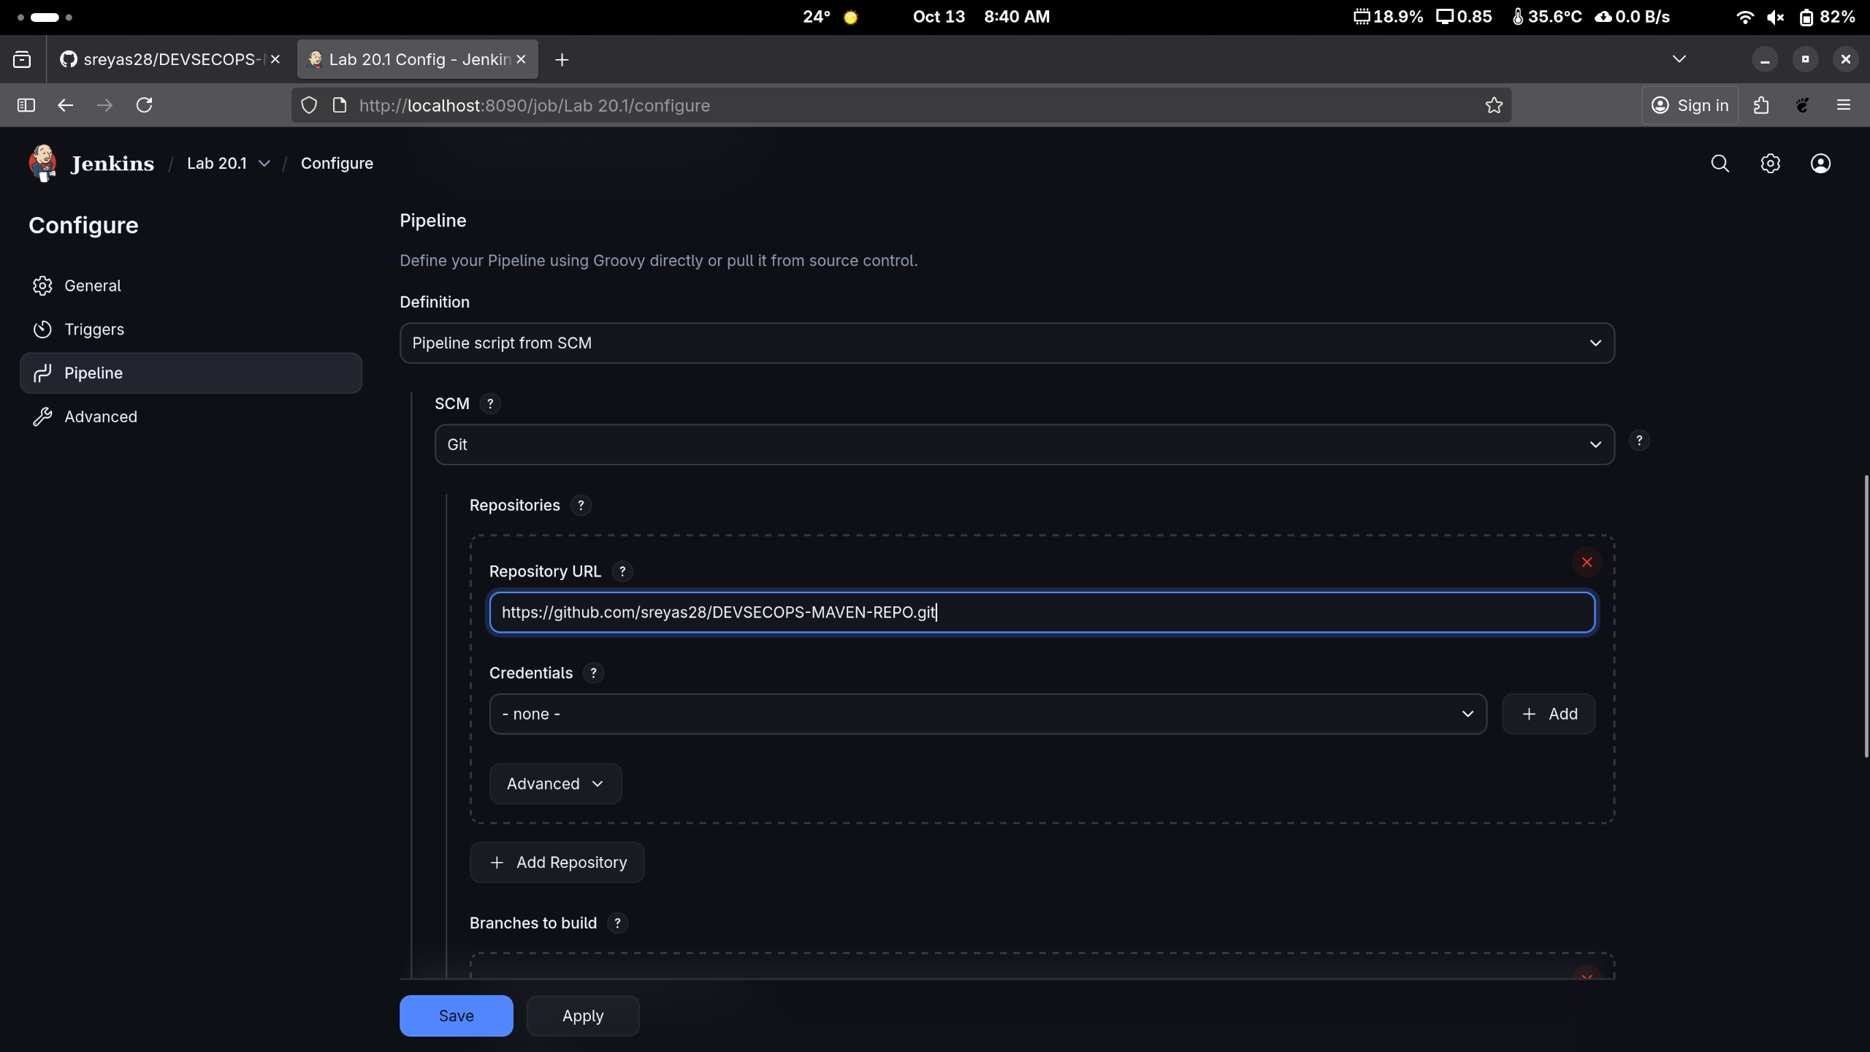Select “PipeLine Script From SCM” in defination then Select Git And then Paste The URL.

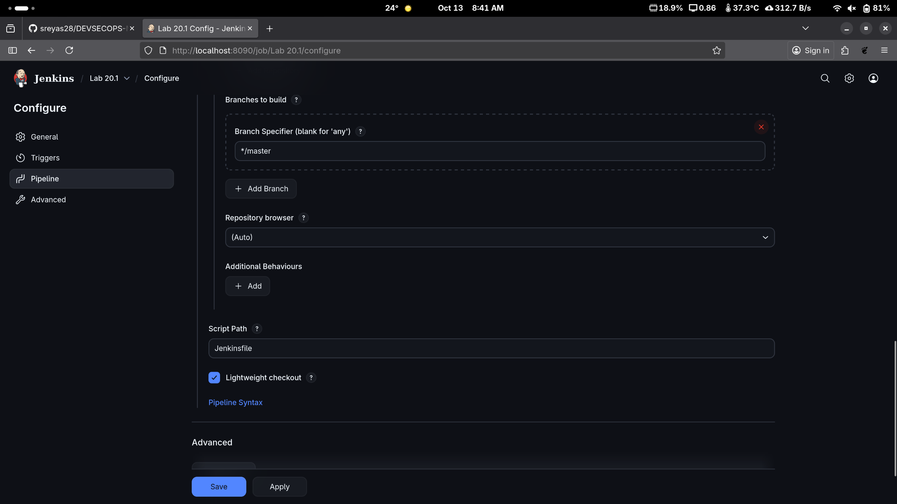

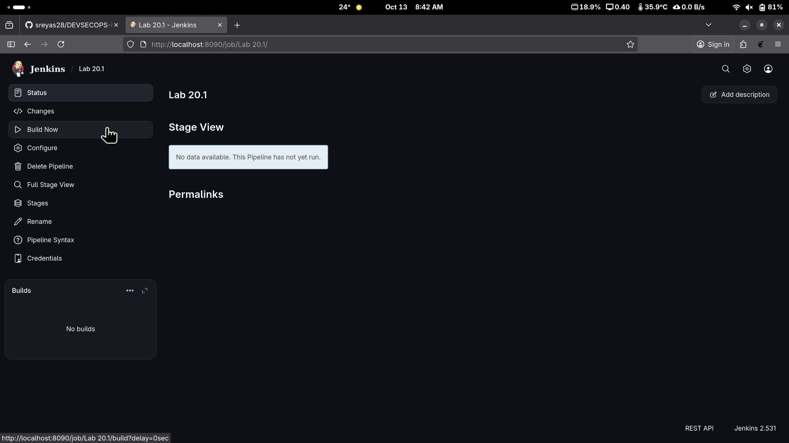

Step:4 after Clicking Save Click on “Build Now”.

Step:5 Now you see The Pipeline doing the thing.

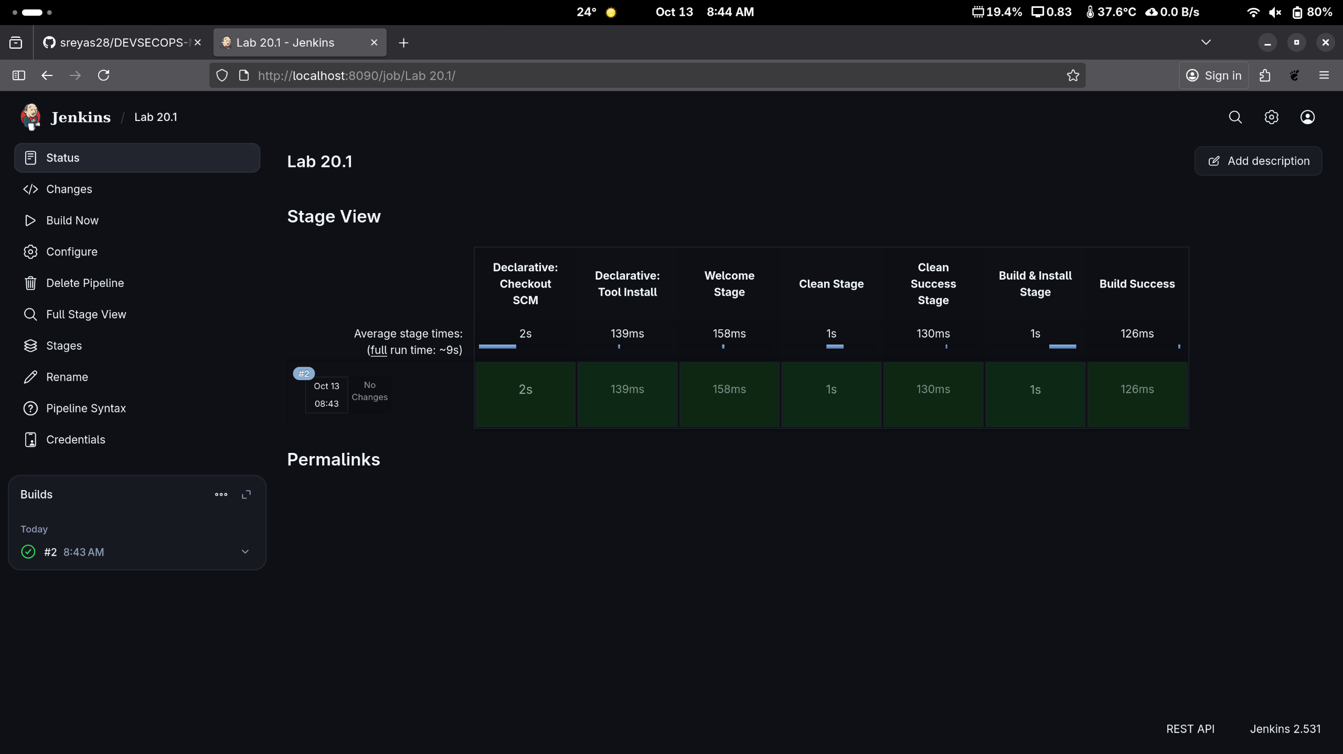

Step: 6 (Optional) Setting up Poll SCM. Now it will fetch changes from the SCM in every minutes

